2019  Hayfield Summer Recreation | New Field Trip!  Air Insanity Trampoline Park  ────  Tons of trampolines with fun activities including jousting, dodgeball, nerf wars and much more!  ────  Hayfield summer recreation  9 6th Ave SE  Hayfield, MN 55940  507-477-3235  hayfieldsummerrec.yolasite.com  June 3rd – August 2nd

It’s almost that time of year again!

General Information
The Hayfield Summer Recreation staff alongside Hayfield Community Schools is excited to offer a range of learning opportunities and exciting activities. Depending on the activity, we will have opportunities for kids of all ages – from preschool to high schoolers.

Zach Nelson will be taking over day-to-day operations of all summer recreation activities. For example, he will be the lead chaperone on all field trips alongside Rachel Dublin and Abbey Hansen of the SACC group. Any cancellation questions should also be directed to him.

High School Office Hours (Summer)

Monday – Thursday
7:30 am – 3:00 pm

Phone: 507-477-3235

Summer Recreation Coordinators
Dani Wagner
Email: dwagner@hayfield.k12.mn.us
Phone: 507-272-4191

Zach Nelson
Phone: 507-951-1827

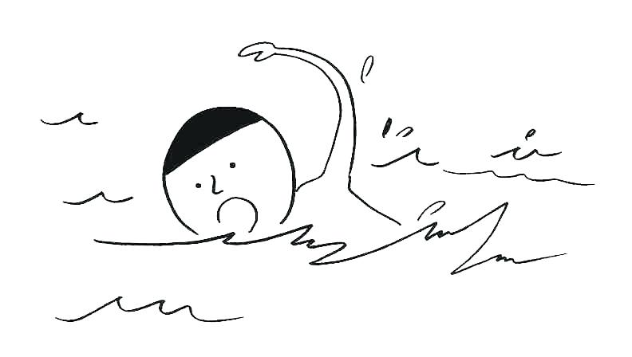

‘Like’ us on Facebook for activity updates and information: www.facebook.com/hayfieldsummerrecreation

Check out our website for schedules, team rosters and other updates:
hayfieldsummerrec.yolasite.com

Boys and Girls Basketball
ATHLETICS
Who Date/Day Location Time Fee
Boys, Grades 1-6 June 3 M-Th East Gym 10:00-11:30 am $15
Girls, Grades 1-6 June 3 M-Th West Gym 10:00-11:30 am $15

Girls Volleyball
Who Date/Day Location Time Fee
Grades 2-6 June 10 M-Th East Gym 10:00-11:30 am $15

Bowling
Who Date/Day Location Time Fee
Grades 3+ June 24-26 M-W Uncle Mony’s 9:30-11:00 am $15

Dance
Who Date/Day Location Time Fee
Grades K-5 July 19 & 20 HS Gyms 9:00 am-3:00 pm $30
**Flyer attached at back for more information**

Wiffleball
Who Date/Day Location Time Fee
Grades 3-6 July 22 M-Th City Field – Grass 9:30-11:00 am $15

Tee Ball
Who Date/Day Weeks Location Time Fee
2018-19 Pre-K and K June 3 M 8 City Field 6:00/7:00 $45
June 5 W 1:00/2:00

Coach Pitch
Who Date/Day Weeks Location Time Fee
2018-19 Grade 1&2 June 4 T 8 City Field 6:00/7:00 $45
June 6 Th 1:00/2:00

Youth Baseball League
Please contact Kasey Krekling for more information - 507-259-0192, kreklka@hayfield.k12.mn.us

Youth Softball League
Please contact Lisa Rueckert for more information – 507-438-7315, rueckert_lisa@yahoo.com

Junior Golf
Junior Golf information is not included in the packet at this time. Junior Golf will continue to be on Thursday mornings at the Oaks. More information can be found at the course or on the Oaks Facebook page.

Swimming Lessons
See attached form at back
Arts & Crafts
EXPLORE
Who Date/Day Location Time Fee
All ages June 6/7th Th/F TBD 3:00-4:30 pm $20

July 11/12th Th/F TBD 3:00-4:30 pm $20
**The first camp will include a tie-dye shirt and wood project with hooks for hanging awards and the second will include a tie-dye pillow case and a wood project to hang pictures on. Additional smaller projects will also be available time permitting.
Valleyfair
FIELD TRIPS
Who Date/Day Location Time Fee
All ages, at least 48” tall May 29 Shakopee 8:00-8:30 pm $45

Bowlocity/Oxbow/Dairy Queen
Who Date/Day Location Time Fee
All ages June 12 Rochester/Byron 8:30 am-3:30 pm $30

Como Zoo & Waterpark
Who Date/Day Location Time Fee
All ages June 26 Saint Paul 8:00 am-6:00 pm $30

Air Insanity/Stewartville Waterpark
Who Date/Day Location Time Fee
All ages July 10 Rochester/Stewie 9:15 am-4:30 pm $30

Twins Game
Who Date/Day Location Time Fee
Adults & grades 3+ July 19 Minneapolis 5:00 pm-12:00 am $45

Grand Slam
Who Date/Day Location Time Fee
Grades 1+ July 24 Burnsville 9:30 am-3:30 pm $30

Kasson Waterpark
Who Date/Day Location Time Fee
All ages August 7 Kasson 11:00 am-4:00 pm $15

REGISTRATION FORM
Due date: May 10th

Student Name:__________________________________________________ 2018-19 Grade _________

Parent/Guardian Name: _________________________________________________________________

Phone Number(s): _____________________________________________ Student T-shirt size: _______
(Tee ball and coach pitch only)

Activity | Date/Level of Competition | Cost
Boys/Girls Basketball | June 3rd-6th | $15 x =
Girls Volleyball | June 10th-13th | $15 x =
Bowling | June 24th-26th | $15 x =
Wiffleball | July 22nd-25th | $15 x =
Arts & Crafts | June 6th & 7th | $15 x =
 | July 11th & 12th | $15 x =
Dance | July 19th & 20th | $30 x =
Tee Ball | Pre-K & Kindergarten | $45 x =
Coach Pitch | 1st & 2nd Grade | $45 x =
**Please indicate here if you would like your child on the same team as another child.
Field Trips
Valleyfair | May 29th | $45 x =
Bowlocity/Oxbow/Dairy Queen | June 12th | $30 x =
Como Zoo & Waterpark | June 26th | $30 x =
Air Insanity/Stewie Waterpark | July 10th | $30 x =
Twins Game | July 19th | $45 x =
Grand Slam | July 24th | $30 x =
Kasson Waterpark | August 7th | $15 x =
Total Cost

Release – Assumption Risk
The undersigned, being a parent or guardian responsible for the health and welfare of the above named student who is under the age of 18, understands and agrees to assume the risk of any injury, illness or accident that may occur during the course of the Summer Recreation Program. I/We agree to hold Hayfield School Board, school district employees and agents forever harmless from and against any and all liability, loss, damage, costs, charges, claims, causes of action, recoveries, judgment, penalties, and expense arising from or in connection in any way whatsoever with this program.

Parent/Guardian Signature: ___________________________________________________ Date: ___________________

